**Installation of Hyperledger Fabric:**

The below document details the steps and procedure to install Hyperledger Fabric into a system and steps to create first network on the ledger.

**Overall Steps:**

1. Create AWS student account: Login to given url: <https://portal.aws.amazon.com/billing/signup> and create a AWS account with uncc email id. On creation of account create a AWS educate account on the portal : <https://aws.amazon.com/education/awseducate/apply/>. Use the aws id while creating the account to avail $100 credit for uncc students.
2. Create ec2 instance: After creating AWS account login to the aws console and create a ‘EC2’ instance in the portal as shown below.

* Click on EC2 in ‘Compute section.

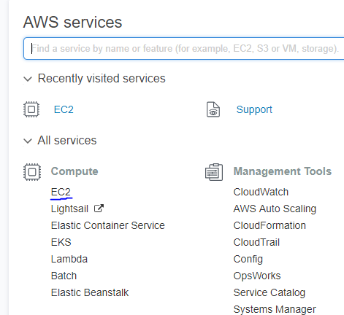

* Click on Launch Instance

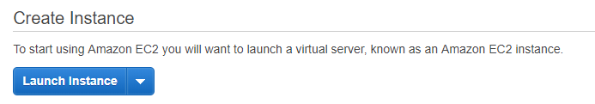

* Next click on Ubuntu Server 16.04 as shown below

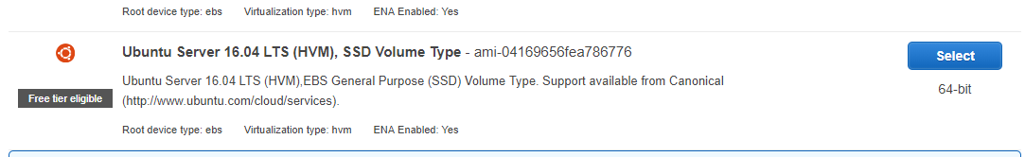

* Next generate go through the general steps and create a key pair for the instance.
* Ensure the instance is running by going to ‘Instances’ tab as shown.

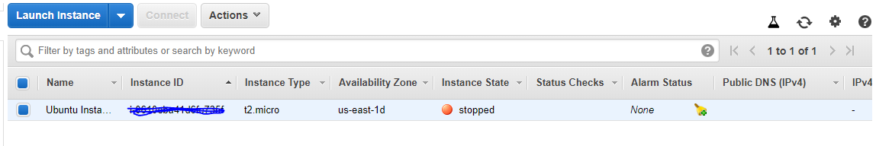

1. If windows user, install virtual box and ubuntu 16.04.: Go to url: <http://releases.ubuntu.com/16.04/> and download 64 bit desktop image. Then go to <https://www.virtualbox.org/wiki/Downloads> and download virtual box setup. Run the setup and install virtual box on your machine in general specified manner. Run the executable and check if install Ubuntu OS from the iso file downloaded earlier. General implementation will look like below.

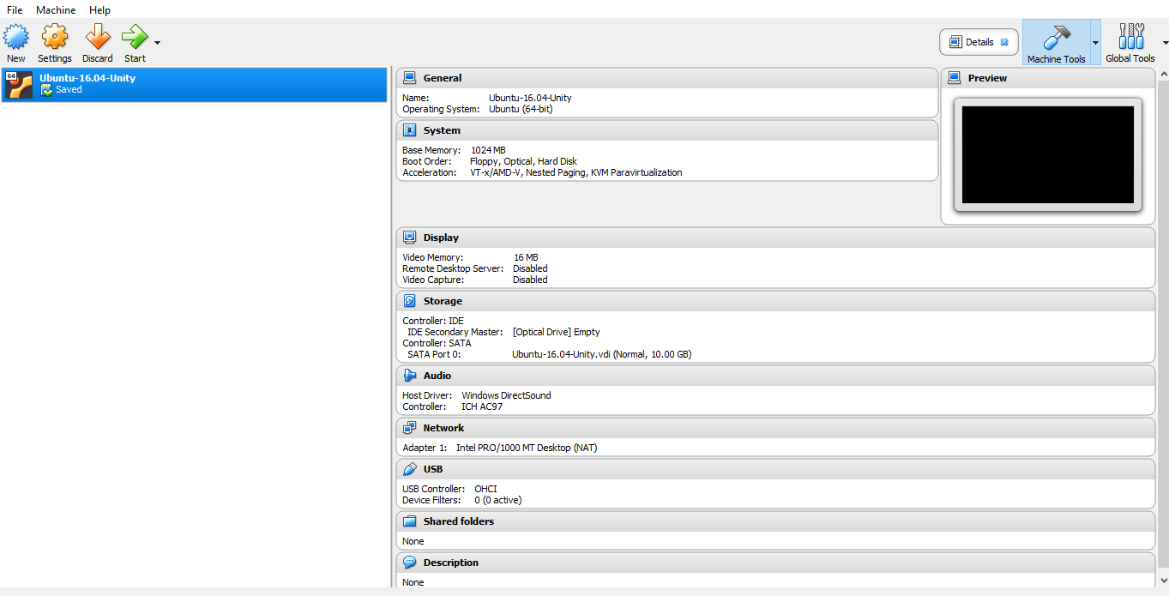

1. Install prerequisites: Install prerequisite softwares like Git, GO, docker, etc in the manner as mentioned below in the virtual machine instance. Also refer the following url: https://hyperledger-fabric.readthedocs.io/en/latest/prereqs.html
2. Install hyperledger and fabric samples. Create a repository in your Virtual instance for storing hyperledger and its sample. Now go to the directory through the terminal and as mentioned here (<https://hyperledger-fabric.readthedocs.io/en/latest/install.html>) run the below command.

*curl -sSL http://bit.ly/2ysbOFE | bash -s 1.2.0*

1. Create first network: Follow the guide below to create your first network.

**Installing Prerequisites:**

Open the terminal and use the below commands to install.

* + Install git : Use the below commands to install Git.

apt-get update

apt-get install git-core

git --version

* + Install curl using below commands

sudo apt install curl

curl --version

* + Install python:Python 2 (not 3): Linux and Mac must already have it, but make sure version 2 is active with python command

sudo apt update

sudo apt upgrade

sudo apt install python2.7 python-pip

* + Install node

sudo apt-get update

sudo apt-get install nodejs

sudo apt-get install npm

nodejs -v

* + Install Go

sudo apt-get update

sudo apt-get -y upgrade

wget https://dl.google.com/go/go1.10.3.linux-amd64.tar.gz

sudo tar -xvf go1.10.3.linux-amd64.tar.gz

sudo mv go /usr/local

#In bashrc set

export GOROOT=/usr/local/go

export GOPATH=$HOME/digcerti

export PATH=$GOPATH/bin:$GOROOT/bin:$PATH

# verify installation

go version go1.10.3 linux/amd64

* + Installing Docker
    1. First, add the GPG key for the official Docker repository to the system:

curl -fsSL https://download.docker.com/linux/ubuntu/gpg | sudo apt-key add -

Add the Docker repository to APT sources:

sudo add-apt-repository "deb [arch=amd64] https://download.docker.com/linux/ubuntu $(lsb_release -cs) stable"

* + 1. Next, update the package database with the Docker packages from the newly added repo:

sudo apt-get update

Make sure you are about to install from the Docker repo instead of the default Ubuntu 16.04 repo:

apt-cache policy docker-ce

* + 1. Finally, install Docker:

sudo apt-get install -y docker-ce

Docker should now be installed, the daemon started, and the process enabled to start on boot. Check that it's running: sudo systemctl status docker add your username to the docker group:

sudo usermod -aG docker ${USER}

You will be prompted to enter your user's password to continue. Afterwards, you can confirm that your user is now added to the docker group by typing:

id -nG

Docker compose Run this command to download the latest version of Docker Compose:

sudo curl -L https://github.com/docker/compose/releases/download/1.22.0/docker-compose-$(uname -s)-$(uname -m) -o /usr/local/bin/docker-compose

Apply executable permissions to the binary:

sudo chmod +x /usr/local/bin/docker-compose

Test the installation.

$ docker-compose --version

**Create first network:**

1. Enter into the first-network directory
2. Generate the required certificates and articates for your first network

$ ./byfn.sh -m generate

To see the generate certificates use the following command:

$ cd crypto-config

$ ls

1. Create your first network using the following command

$ ./byfn.sh -m up

1. Check the generates images and running containers using the following command:

$ docker images

$ docker ps

1. To bring down the created network executed the following command

$ ./byfn.sh -m down

1. You can check the created images have been removed using the following:

$ docker images